 v

**Version 2.0**

**April 29, 2013**

**Carrier Payment Interface Control Document**

1. Table of Contents

1 Introduction 1

2 Service Overview 2

2.1 Purpose 3

2.2 Functionality 3

2.3 Participants 4

2.4 Service Obligations 4

2.5 Out of Scope 5

3 Assumptions and Issues 5

3.1 Assumptions 5

3.2 Issues 5

4 General Interface Requirements 6

4.1 Functional Summary 6

4.2 Business Process 7

4.2.1 Enrollee Data Flow 7

4.2.2 Premium Payment Flow 8

4.2.3 Payment Data Flow 8

4.2.4 Fund Transfer Flow 8

4.3 Service Operations 9

4.4 Data Handling 9

4.5 Process Controls 9

4.6 Security and Integrity 10

5 Detailed Interface Design 10

5.1 Event Sequence 12

5.2 Service Request Data 13

5.3 Service Response Data 13

5.4 Packaging and Delivery 13

5.4.1 Technical Plan – SFTP Exchange 14

5.4.2 System Architecture 14

5.5 Transactional Requirements 14

5.6 Security Management 15

5.7 Business Rules 15

5.8 Exception Handling and Problem Resolution 15

5.9 Service Performance 15

6 VT HBE Process Implications 16

7 General Qualification Plan 16

Appendix A: Acronyms 17

1. Table of Figures

Exhibit 1: Functional Overview 6

Exhibit 2: Payment Flow 8

Exhibit 3: Service Operations – Carrier Web Services 9

Exhibit 4: Service Operations – VT HBE Web Services 9

Exhibit 5: High Level System Components 11

Exhibit 6: Financial Management Message Sequence 12

Exhibit 7: SFTP Exchange Technical Plan 14

Exhibit 8: List of Acronyms 17

**Revision History**

|  |  |  |  |
| --- | --- | --- | --- |
| Version | Date | Modified By | Description |
| 1.0 | 03/15/13 | David Jurk | Initial draft |
| 2.0 | 04/29/13 | David Jurk | Final – per carrier and State discussions of changes |
|  |  |  |  |
|  |  |  |  |
|  |  |  |  |
|  |  |  |  |
|  |  |  |  |

# Introduction

The Vermont Health Benefit Exchange (VT HBE), at its heart, serves as a facilitator between carriers and Vermont citizens in achieving healthcare coverage for individuals and employees, and their households. The VT HBE also serves as the system of record for those enrollments, as well as the premiums and the payments of those premiums.

This document describes the service implementation processes and interfaces for providing premium payment data to Carriers and the remittance of the monies themselves. It also describes related messaging operations that support the payments process.

The scope of this Interface Control Document (ICD) is intended to encompass, in a broad sense, the overall flow of premium monies and payment data through the system, as well as specific information regarding communication exchanges between VT HBE and the Carriers. It is not intended to provide full business process descriptions, nor does it comprehensively attempt to address information exchanges between the VT HBE and other, non-carrier, parties.

Full details of all relevant document interfaces, transaction processes, and operational protocol are addressed within this document. Supporting documents that may add additional insights into specific aspects of the process are referenced.

The *Carrier Payment ICD Companion Guide* to this ICD provides further details related to the various message structures used to convey payment and remittance data to the Carriers.

# Service Overview

Carrier Payments involve four fundamental message exchange operations:

1. The communication of individual and employer enrollment and premium data - between the VT HBE System and the Premium Processor.
2. The communication of individual and employer payments received - between VT HBE and the Premium Processor and between VT HBE and the Carriers.
3. The transfer of funds collected for premiums - between the Premium Processor and Carrier banks.
4. Communication of partial payments and payment artifacts (letters and documents related to payment) - between Premium Processor and VT HBE. Note that VT HBE will make these artifacts available to Carriers upon request.
5. Transfer of files between VT HBE and Carriers of historical payment records for reconciliation purposes, invoice data and whatever additional reports are required over time.

For purposes of this ICD, while the overall business flow is described for context purposes, the ICD itself is focused on the concrete interfaces (and their messages) needed to support payment processing as it occurs between VT HBE and the Carriers.

To that end, there are three areas of data exchange in scope for this ICD:

1. **From the Vermont HBE to the Carriers**
   1. To transmit premium payment activity for an employer or individual
   2. To transmit detailed remittance data for funds moved to the Carriers’ banks
   3. To transmit invoice data
2. **From the Premium Processor to the Carriers**

* To remit funds from the State of Vermont settlement account to the Carriers’ banks

1. **From the Carriers to the VT HBE**

* To transmit validation errors resulting from remittance messages sent by the VT HBE

## Purpose

The Vermont HBE is intended by the Affordable Care Act (ACA) to be a facilitator in the provision of healthcare coverage to its eligible citizens seeking it. It is intended to bring issuers and applicants together and streamline and operationally ease the task of applying for and enrolling in a healthcare plan. To that goal, the State of Vermont (SOV) has established a partnership with a third-party Premium Processor to manage all aspects of invoicing and payment receipt related to the handling of plan premiums for VT HBE enrollees, with the exception of activities related to late payments and related collection activities.

## Functionality

* **Notification to the Carrier of enrollee premium payment**

At the time an individual enrolls in a plan, their payment type is identified and their VT HBE exchange data and data needed for the payment are gathered and transmitted to the Premium Processor via a Web Service call. When the Premium Processor receives the payment (credit card, check or ACH), they send record of that payment to VT HBE, which carries out the enrollment by sending an enrollment message to the Carrier. Note that no payment data is sent for initial enrollment – the payment is implied by the enrollment itself.

For ongoing payments, enrollees remit directly to the Premium Processor. As full premium payment is satisfied, the Premium Processor sends nightly payment notification to VT HBE, which in turn passes it along to the appropriate carriers.

Note that partial payments or overpayments are not conveyed to the carrier. As partial payments accumulate to full premium payments, they are then appropriately reported. Overpayments are reported for the period they apply to.

* **Notification to the Carrier of funds remittance**

Weekly, the central State account is swept for funds that have settled during the previous week (Monday through Friday), and are remitted out to the appropriate carrier and bank accounts. The Premium Processor sends a remittance message to VT HBE, who passes it on to the Carriers. The remittance message carries sufficient information to explain the complete allocation of funds related to the deposit that was made, and ties the message to the deposit via a transaction ID.

* **Transmit Invoices**

Invoice data are provided to VT HBE at the point they are ready to generate invoices to enrollees. VT HBE will repackage those data into a flat-file, comma delimited, machine-readable format for processing by the carriers.

Note that historical payment data, as well as other reports, will be made available to carriers for purposes of reconciliation, internal process augmentation, etc., but their structure, content and timing are outside the scope of this ICD and accompanying *Carrier Payment* *ICD* *Companion Guide*.

## Participants

* **VT HBE**

VT HBE here refers generically to the VT HBE System, which is actually comprised of several architectural layers. Of particular interest to this ICD is the VT HBE Integration Hub (HIH), the infrastructure of which is built using the Oracle SOA Suite, and comprising a set of services – the interfaces for which are described in the series of ICD artifacts.

In addition, the VT HBE Portal (a Liferay implementation with Exeter OneGate customizations) plays a crucial role in these processes, as it is typically the layer which initiates these service calls as the business client, working through the HIH service layer and on to external sources such as the Carriers.

For payment processing, the non-public portion of the VT HBE system – the Customer Service layer – is a significant part of the overall solution. Carriers needing to verify premiums, track partial payments, resolve payment disputes, identify physical artifacts such as canceled checks, and a myriad of other tasks, will need to call a CSR resource to explore these details. All of the Customer Service operations are out of scope of this document.

* **Carriers**

The Carriers here refer to QHP issuers for citizens utilizing the VT HBE system (either through the Portal or through Customer Walk-or-Call in Centers). Specifically, in terms of these ICD artifacts, Carrier refers to some defined infrastructure such as a Carrier-provided Web Service or Secure FTP file repository.

* **Premium Processor**

This role refers to a third-party agency contractually engaged to handle most aspects of premium invoicing, premium collection, invoice generation, and notice and artifact (that is, payment documents) routing. Out of scope for this role is all dunning, late payment collection activity, etc., which is the responsibility of the Carriers.

## Service Obligations

* **VT HBE**

VT HBE serves as the system of record for all matters related to enrollments and payment. As such, it is the central authority and repository. All aspects regarding payment must be reflected in the VT HBE, and be available for review should an enrollee call with questions, or should partner agencies such as Carriers desire detailed review of an enrollment or payment. So, the service obligations of the VT HBE involve providing the means by which these materials and data messages can be exchanged.

In addition, the VT HBE is responsible to provide a web service to receive remittance message validation errors.

* **Carriers**

The Carriers service obligations, then, are:

* Provide web services for the receipt of payment activity and fund allocations
* Provide FTP locations for the receipt of invoice files
* Serve as a “courier” for payments directly received, sending them on to the Premium Processor in prompt fashion for normal processing
* **Premium Processor**
* Remit collected premium payments to the Carriers’ banks.
* Convey payment activity, remittance detail, and all payment related artifacts and documentation to VT HBE.

## Out of Scope

From an interface definition perspective:

* Specific interface document details between the premium processor and VT HBE
* Specific transaction details between the premium processor and individual enrollees and employers Reconciliation processes and reporting data
* Problem resolution processes

# Assumptions and Issues

This section discusses assumptions and issues with the VT HBE project.

## Assumptions

The following assumptions have been made concerning the VT HBE project:

* The premium processor will be the default provider of all payment handling, including validation and settlement, for all premiums collected, including the initial payment.
* Payments made to other parties (e.g., Carriers) will need to be sent to the premium processor for normal payment processing flow to occur.
* The premium processor will *not* be providing reminders, dunning activities, late-payment collection attempts, etc.
* All carriers will host web services, as described below, with industry-standard security mechanisms as described in the *Carrier Payment* *ICD* *Companion Guide*.
* Carriers will need to establish and communicate bank accounts to receive collected premiums through a State of Vermont bank via ACH.

## Issues

The following are issues still in OPEN status with the VT HBE project:

|  |  |
| --- | --- |
| Issue | Status |
| The exact process for conveying extraneous payments (“walk in” payments from enrollees) from Carriers to Premium Processor in a fashion to expedite processing needs to be addressed | Open |
| The problem resolution process, as noted in the Companion Guide, is virtually entirely manual, and requires collaboration between the State and the carriers to be developed. It is outside the scope of this ICD and Companion Guide | Open |
| Need to ensure that all change scenarios have been identified | Open |
| The Invoice file format needs to be specified | Open |

# General Interface Requirements

## Functional Summary

As briefly described previously, the services related to premium payment collection, notification of that payment, and invoice data involve three parties – VT HBE, Carriers, and the Premium Processor.

As the Functional Overview diagram below indicates, there is a redirection of control in several places in the processing flow, largely due to the role that the Premium Processor plays and the fact that VT HBE serves as the system of record.

That redirection is demonstrated in the following fashion:

* VT HBE collects, and provides to the Premium Processor, sufficient information for it to carry out ongoing billing and receiving of enrollee payments. VT HBE serves, in effect, as a facilitator in that sense; once the relationship between Premium Processor and enrollee is initiated, neither VT HBE or the Carrier is routinely involved with billing or payment receipt. However, it is important to note that VT HBE is the sole system of record, utilizing information from both Carriers and Premium Processor to maintain the financial state of its enrollees.
* The Premium Processor does not directly send formal payment notice to the Carriers; that responsibility belongs to the VT HBE. There is, in fact, no routine communication directly between Carrier and Payment Processor, other than the remittance of funds to Carriers’ banks

Redirection of communication from the Premium Processor to the Carrier occurs with VT HBE acting as the agent, receiving payment and remittance messages, repackaging them with Carrier-specific data, and sending the repackaged messages on to the Carriers.

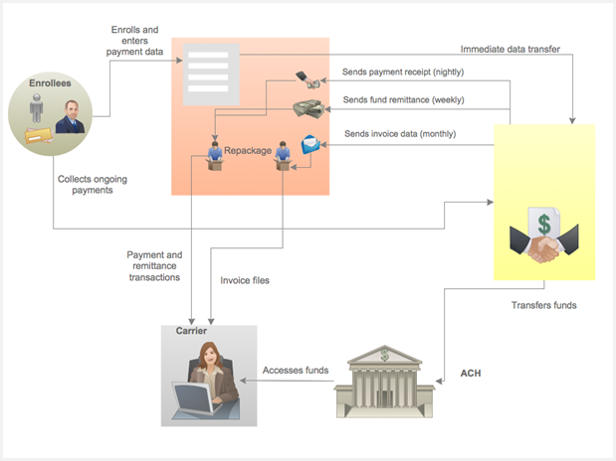

Exhibit : Functional Overview

The general sequence of steps, as shown, is as follows:

1. The individual enrollee, or the employer, trigger the need for premium payment processing, by either enrolling in a QHP (individual) or closing open enrollment with active employee enrollments in a Group (employer).
2. Payment data are collected in the VT HBE system and immediately sent via web service to Premium Processor with necessary enrollee information (exchange identification and plan enrollment details). This might mean credit card or ACH transfer data immediately sent to Premium Processor, or intention of enrollee to send a check to Premium Processor.
3. Premium Processor sends payment activity to VT HBE (assuming payment has 100 percent satisfied premium amount), who then sends payment receipt notification to the Carrier.
4. Weekly, each Wednesday, the central State of Vermont account is swept for settled funds (as of the previous week’s Monday – Friday), which are then remitted to appropriate carrier bank accounts. The Premium Processor sends remittance details of those transfers to VT HBE, who sends the details on to the Carriers.

## Business Process

From a business process standpoint, in terms of the scope of this ICD, while the nuances of money movement are complex and potentially involve several potentially long-running steps, reversals, etc., the messaging involved is straight-forward, and involves:

* The flow of enrollee data from VT HBE to the premium processor
* The flow of payments from enrollees to the premium processor (including partial payments and overpayments)
* The flow of premium payment data, fund allocation information, and invoice data from VT HBE to the Carrier
* The flow of funds from the premium processor to the Carriers’ banks
* The flow of backup documentation (check images, letters, etc.) from the premium processor to VT HBE

### Enrollee Data Flow

The Premium Processor requires several types of information to carry out its role as payment receiver and manager:

* Enrollee identifying data used for communicating with enrollee and identifying paper materials sent to Premium Processor
* VT HBE identifying data (Exchange ID)
* Plan data (Carrier ID, Plan ID, net premium amount, etc.)

This is carried out upon initial enrollment, and updated when any significant change event occurs.

### Premium Payment Flow

There is only one formal mechanism for registering and processing payment of premiums, and that is via the Premium Processor. The initial enrollment payment that is provided via credit card or ACH via the VT HBE portal is, in effect, just a convenience for the enrollee. This payment, from a processing standpoint, is no different that the ongoing payments that follow.

The implication of a single payment channel means that for all variations of this theme – reversals, credits, reimbursements, etc., they too must all be processed – and funds allocated and paid – via the Premium Processor.

### Payment Data Flow

Payment data includes three types of information:

* Notification that payments have been received
* Notification that funds have settled and been remitted
* Provision of invoice data

These data, from a Carrier’s perspective, are always provided by the VT HBE. In the case of the first two, they are conveyed via web services in a transactional fashion, and in the case of invoices, via a file transfer.

### Fund Transfer Flow

Fund transfer flow is the movement of monies from the central Vermont settlement account to the Carrier’s banks. While there are accounting nuances (e.g., debits pulled from succeeding remittances as opposed to “pulling” money back from Carrier banks), from an interface perspective, there is virtually no involvement of the VT HBE system itself.

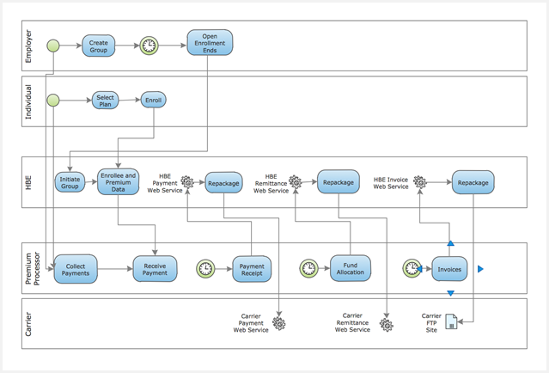

Exhibit : Payment Flow

## Service Operations

Exhibit : Service Operations – Carrier Web Services

|  |  |  |
| --- | --- | --- |
| Service Host | Operation | Triggering Event |
| Carrier | Payment Web Service – Provides an endpoint for VT HBE to send the payment notification message to the Carriers | Premium payment received by Premium Processor |
| Carrier | Remittance Web Service – Provides an endpoint for VT HBE to convey funds remittance, describing detailed allocation of deposits to Carrier’s bank | Distribution of funds from State settlement account from prior week (M-F) |

Exhibit : Service Operations – VT HBE Web Services

|  |  |  |
| --- | --- | --- |
| Service Host | Operation | Triggering Event |
| VT HBE | Remittance Callback Web Service – Provides an endpoint for Carriers to send validation errors for remittance messages sent by VT HBE | Remittance message received by Carriers |

## Data Handling

The Carriers will provide a SOAP-based Web Service that the VT HBE System will call to convey an EDI X12N 820, indicating a payment notification. This message and the significant data elements it contains are described in the *Carrier Payment* *ICD* *Companion Guide* accompanying this document.

The Carriers will provide a SOAP-based Web Service that the VT HBE System will call to convey an EDI X12N 820 (CMS FFE standard) fund remittance document, indicating detailed account and remittance data. This message, and the significant data elements it contains are described in the *Carrier Payment* *ICD* *Companion Guide* accompanying this document.

VT HBE will host a SOAP-based Web Service that the Carriers will call in response to receiving remittance messages (EDI 820 transactions) that do not pass EDI validation. This would be provided via an EDI standard 999 message, unless Carriers choose to use a simpler message structure (TBD).

VT HBE will provide Invoice data to the Carriers, as a comma-delimited, machine-readable file via SFTP exchange, indicating full billing detail going from the Premium Processor to the enrollees, by Carrier. The structure and contents of the Invoice data file are pending, to be determined by Carriers.

## Process Controls

The general goal of process controls is to ensure that whether the transactional protocol is file based or web service based, procedures are in place to deterministically monitor message delivery and response.

For Web Service based messaging, the operational controls include:

* The provision of formal WSDL definitions and associated XSD’s for all services
* Expectation of synchronous acknowledgement of all request messages
* Detailed logging of all messaging and data movement
* Standardized transmission security controls (see security section later in this document)
* ‘Ping’ mechanisms to monitor service availability
* SOA Suite BAM event triggers to monitor and report on message activity and behavior

## Security and Integrity

Security for any Health Exchange and its partners is absolutely paramount. Federal guidelines mandate adherence to high standards, and these standards provide an overarching umbrella over all data exchanges and the various infrastructures, mechanisms, and operations providing those data.

In general, processes and technology must be provided to effectively secure the following aspects of data exchange covered by the ICD:

* Secure encryption/decryption mechanisms and techniques for all data movements
* Secure, standardized definition and implementation of web services security
* Comprehensive authentication mechanisms for web service calls and SFTP transfers
* Comprehensive logging of all activity related to data movement
* Secure infrastructure, according to CMS security guidelines, in the provision of Web Service endpoints

Please refer to the *Carrier Payment* *ICD* *Companion Guide* to this document for a more comprehensive review of web service standards that will apply, as well as an SFTP framework designed to help maximize security and reliability of file transfer

# Detailed Interface Design

The scope of the Carrier-PMT ICD encompasses four discrete layers architecturally:

1. The VT HBE OneGate system comprised of a customized Liferay portal, and numerous Oracle products, primary among them Siebel, SOA Suite, IDM and WebCenter Content. This system should in general be viewed conceptually as the system front-end, with the Liferay portal providing the web-based UI for users accessing the system from a browser, and customer service and call center resources accessing data, administrative screens and processes through the Siebel CRM applications.
2. A logical “mediation layer” comprised of SOA Suite composites (mediators, BPEL processes, and adapters) whose purpose is to provide access for the Portal and Siebel applications to external services. This layer is referred to as the VT HBE Integration Hub (HIH).
3. The Carrier infrastructures providing specific SOAP-based Web Services and SFTP file transfer directories.
4. The Web Service provisions and background payment processing functionality provided by the Premium Processor, the single-source payment provider for VT HBE.

In general, the topology of these systems forms a single access point, or gateway, between the broad application functionality of the ‘front end’ and the services provided by external resources, such as carriers and the payment provider. The purpose of this is to provide control and tracking of traffic between service providers and clients, and to help ensure that the business process implications of many of these external services are fully visible and managed.

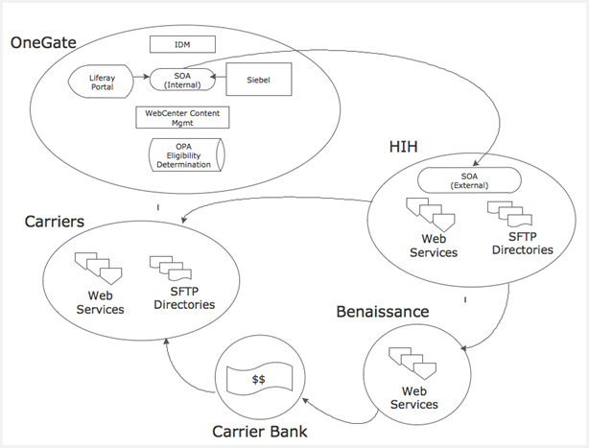

Exhibit : High Level System Components

The diagram above provides a high-level overview of the components comprising the VT HBE infrastructure. The critical concept to extract from this diagram is that the OneGate system itself is logically isolated from external interfaces, with all traffic being routed through the Vermont HBE Integration Hub, which provides a set of Web Services and SFTP directories and functions to provide a mediation layer for data exchange between the VT HBE System and external Vermont Partners such as Carriers and payment processor.

## Event Sequence

The message exchanges and triggering events are few and clearly defined. Depicted below is a sequence showing the event sequence details.

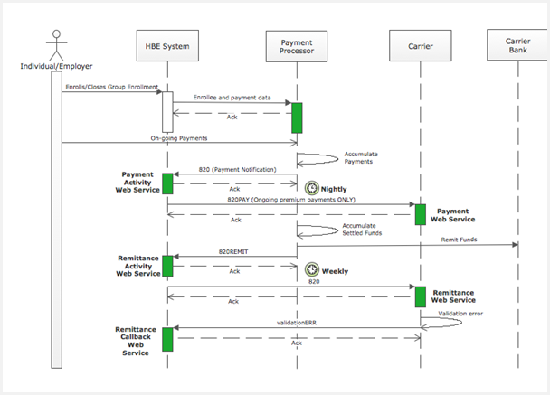

Exhibit : Financial Management Message Sequence

The specific set of steps involved is:

1. Either an initial enrollment or an ongoing payment event triggers the sequence.
2. In the case of an initial enrollment, VT HBE collects payment information and sends it, as well as enrollee identification and contact data, to the Premium Processor. If initial payment is by check, those are remitted directly to the Premium Processor by the enrollee.
3. In the case of ongoing payments, those are also remitted directly to the Premium Processor by the enrollee
4. In either case, on a nightly basis the received payments – defined as a full premium payment – are sent to VT HBE by the Premium Processor in the context of an 820 EDI message, meant to convey receipt of full premium payment. Note – this does not imply settlement, only payment receipt.
5. VT HBE repackages this 820, replacing Carrier-specific data where appropriate, and sends it as a SOAP-based web service call to a Carrier-hosted Payment Web Service.
6. Every week, on Wednesday, the central State of Vermont settlement account is swept, and funds are remitted to Carrier banks, based on the previous week’s settlements (Monday – Friday). The result of that remittance is data sent to VT HBE as an 820 message, containing – among other things – the transaction ID of the deposit.
7. VT HBE repackages that 820 and sends it on the Carrier, providing the means by which the deposit can be tracked and funds accurately allocated. Only in the case of an EDI validation error, the Carrier will send a validationERR message (precise structure TBD) to the VT HBE Remittance Callback Web Service, providing a reason code regarding the validation failure.

## Service Request Data

The Request data structures for 820 and messages, with data descriptions for significant elements, are included in the *Carrier Payment ICD* *Companion Guide* accompanying this document.

## Service Response Data

The Response data structures for 834, 820 and Invoice messages, with full data descriptions, are included in the Companion Guide accompanying this document. At present, the validationERR message is depicted as an EDI standard 999, but the decision to pursue that course or not is pending with the carriers.

## Packaging and Delivery

**For Web Services**:

* Standard WS-Reliable Messaging and WS-Security (version 1.1) standards will be followed
* VT HBE will implement a comprehensive system of BAM event triggers, providing for real-time tracking of traffic activity through the various layers of the SOA composites carrying out the web service provision and consumption
* Comprehensive Logging will also be provided, with both header and body data, as well as network addresses, time of day and operation attempted being recorded for all activity
* See the *Transactions* section below for further identification of Web Service packaging and delivery expectations and management.

**For SFTP**:

* Enrollment operations will be preceded with a notification to the Carrier, in an agreed-upon fashion. This could be email, a web service call, a notification file, or some other procedure.
* All file upload operations will be followed by a small “trigger” file that signifies the file provider completed the primary file upload operation successfully. The presence of a primary file, even an expected one, without the trigger file means the primary file is suspect and a ‘missing file’ resolution process needs to be triggered. The trigger file should meet the naming convention specified below.
* Once a file is successfully received by the target, the receiver is expected to upload a small acknowledgement file to the SFTP directory of the original file’s source, identifying the name of the file received, the date and time it was placed. The acknowledgement file should meet the naming convention specified below. This file is not read and has no content – it is significant only in its appearance in the upload directory.
* Carriers and VT HBE will work out a file naming convention for all files to be exchanged. The naming convention needs to achieve the following goals:
* Each name is guaranteed to be reliably unique
* The name alone will identify the source of the file, the type of operation that it is meant to participate in, the party that is the target of the file, and the day and time it was sent
* All files should be encrypted (the suggested technique is PGP) and sent via SFTP. Carriers and VT HBE will maintain individual key stores in appropriately secure fashion, and keys will be regularly changed.

### Technical Plan – SFTP Exchange

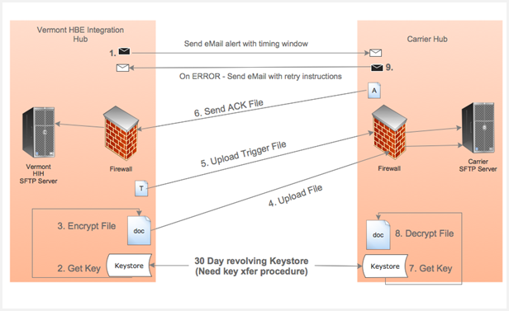

Exhibit : SFTP Exchange Technical Plan

The steps involved in carrying out a single SFTP exchange are described in the proposed technical plan above. The goals of this somewhat cumbersome approach are to help ensure that when a file shows up, it is expected, and if one is expected, its absence is notable.

Further, the explicit pre-transmission encryption helps ensure that even Server operators are not able to view these documents.

Descriptions of specific elements:

* The keystore refresh process is to be jointly agreed upon in collaboration between Carrier technical staff and VT HBE.
* The ‘trigger file’ is a small file that contains no data and is never read. Its only purpose is to signify that the file of interest, the uploaded file containing the data of concern that is uploaded in step 4, has successfully been transferred.

### System Architecture

The system infrastructure is contained in its entirely in other documents unrelated to this ICD and accompanying *Carrier Payment ICD* *Companion Guide*.

## Transactional Requirements

There are no formal transaction requirements represented in this ICD.

## Security Management

Security standards documentation from the State of Vermont Enterprise Architecture area is yet to be published, but in general, the security approach will consist of:

* Web Services will implement comprehensive WS-Security standards
* File transfer operations will use PGP for explicit pre-transmission encryption, and utilize SFTP for file transfers
* Keystores for the encryption/decryption will refresh keys every 30 days

A more detailed explanation and depiction of requirement related to web service security is provided in the *Companion Guide* accompanying this document.

## Business Rules

There are no explicit business rules identified yet for this ICD.

## Exception Handling and Problem Resolution

There are two fundamental families of exceptions that can occur within the scope of message and file exchanges between VT HBE and Carriers:

* **Technical exceptions, consisting of network and software errors**.

These are expected to be handled in a standard fashion; for example, through an agreed upon process of attempted re-tries or a ‘wait’ period before re-tries occur to give system issues opportunity to be resolved. In any case, at some point, even for technical exceptions, it becomes a manual process of tracking problems down, evaluating logs, etc.

These technical exceptions require a procedural handling guide, and the intent of the State is to co-develop that guide in concert with the carrier IT representatives as technical and testing phases get underway.

* **Business logical exceptions**.

These are conditions that occur that involve logical exceptions, not technical. For example, if VT HBE were to send an 820 message (either payment or remittance) to a carrier for an enrollee that it did not have record of, that constitutes a logical error.

Although, for enrollments, a semi-automated logical error process is described, this is not the case with payments. Given that funds are involved, all exception handling is intended – at least at the outset – to be manual.

## Service Performance

No service performance elements exist for the interfaces described in this ICD.

# VT HBE Process Implications

There are no known process implications for the interfaces described in this ICD.

# General Qualification Plan

The *Companion Guide* accompanying this ICD provides a high-level review of the discrete steps that are to be followed to qualify and validate the processes and messages described herein.

Note that subsequent to the delivery of the final ICD and accompanying *Carrier Payment ICD* *Companion Guide*, VT HBE and carriers will begin a technical and testing phase, during which implementation details and testing and qualification procedures will be co-developed and documented in an *Implementation Guide*.

Appendix A: Acronyms

The following table is a list of acronyms introduced in this document.

Exhibit : List of Acronyms

|  |  |
| --- | --- |
| Acronym | Description |
| CMS | Centers for Medicare & Medicaid Services |
| ICD | Interface Control Document |
| LDM | Logical Data Model |
| SDD | System Design Document |
| HIH | VT HBE Integration Hub |
| OPA | Oracle Policy Automation |
| PGP | Pretty Good Privacy |
| SFTP | Secure File Transfer Protocol |
| PP | Payment Processor (Benaissance) |